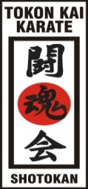
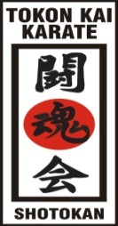
TOKON KAI KARATE

MERCHANIDISE ORDER FORM

Name…………………………………… Dojo………………………………………

ITEM DESCRIPTION | Price | Tick to order | Size/Details required
CLOTHING
GI’s (Karate suits) Lightweight Polycotton
Junior-100cms, 110cms, 120cms, 130cms & 140cms | £20 | []
Cadet-150cms, 160cms & 170cms | £25 | []
Adult-180cms, 190cms & 200cms | £30 | []
Gi’s (Karate suits) Heavyweight –14oz smooth woven cotton canvas
Junior-140cms, 150cms, & 155cms | £60 | []
Cadet -160cms,165cms,170cms & 175cms | £65 | []
Adult-180cms, 185cms, 190cms, 195cms & 200cms | £75 | []
TRACKSUITS
Junior- 2XS, 3XS, 4XS, 5XS, 6XS & 7XS | £55 | []
Adult- XS, S, M, L, XL, 2XL & 3XL | £65 | []
PROTECTION
MITTS-  Colours: red or white  Size: Small, Medium & Large | £15 | []
GUMSHIELD  Junior or senior | £5 | []
BAGS
With club logo
Drawstring | £10 | []
Sports bag | £35 | []
WEAPONS
Foam nunchakus  * Ball bearing | £10 | []
GRADING DOCUMENTS
Syllabus book | £5 | []

Payment options:
1. Bank transfer []
2. Cash []

